2015 APRIL SYNOD AND GENERAL CONVENTION ORIENTATION - MINUTES
The Marlboro Holiday Inn -- 265 Lakeside Avenue, Marlborough, Ma 01752
April 17-18, 2015

PRESENT: 10 Province 1 Synod clergy and lay delegates, 8 Bishops, 2 Executive Council reps, 2 TEC staff, 2 GC staff, 2 Diocesan staff, 48 GC Deputies, 12 GC Deputy Alternates
- SYNOD DELEGATES PRESENT: CT Clergy, Sandra Stayner ; ME Lay, Dick Rozene; ME Clergy, Kit Wang; MA Lay, Billy Boyce; NH Lay Alternate, Eleanor Vander Hagen; RI Lay, Betsy Fornal; RI Clergy, Jan Grinnell; VT Lay, Richard Taylor; VT Clergy, Lee Alison Crawford; W MA Clergy, Nancy Webb Stroud
- SYNOD DELEGATES EXCUSED: MA Lay Alternate, Julie Watt Faqir; W MA Lay, Steve Abdow; W MA Alternate, Margo McMahon and UNACCOUNTED: CT Lay, Sylvia Ho; MA Clergy Alternate, Rebecca Black; NH Lay, Peter Cross; NH Clergy Gail Avery; NH Clergy Alternate, Ray Bonin; W MA Clergy Alternate, Peter Swarr
- BISHOPS PRESENT: Laura Ahrens, Ian Douglas, Tom Ely, Doug Fischer, Gayle Harris, Robert Hirshfeld, Nicholas Knisely, Stephen Lane, (Alan Gates Registered but did not participate)
- TEC: John Colon, Stacy Saul
- GC: Michael Barlowe, Gaye Jennings
- EXECUTIVE COUNCIL: Tanya Wallace, Anne Watkins
- GC DEPUTIES PRESENT: Sarah Ambrogi (NH), Holly Antolini (MA), Kate Atkinson (NH), Stannard Baker (VT ), Beth Baldwin (W MA), Missy Bennett (RI), Lynn Brooks (CT), Anne Brown (VT), Thomas Brown (MA), Rev. Paul J. Carling, Ph. D. (CT), Robin Carlo (W MA), M. Bonnie Chappell (NH), John Cheek (W MA), Randolph Dakes (NH), Jane Gould (MA), Sam Gould (MA), William Exner (NH), Nanci Gordon (VT), Patrick Greene (RI), Brenda Hamilton (ME), Molly James (CT), Jane Jellison (RI), Edwin Johnson (MA), Mercedes Julian (RI), Mick Kalber (W MA), Albert Mollegen (CT), Sarah Neumann (MA), Jennifer S Ogelby (VT), Thom Peters (CT), Nina Pooley (ME), Margaret Porter (NH), Byron Rushing (MA), Elizabeth Ring (ME), Calvin Sanborn (ME), Ben Shambaugh (ME), Rich Simpson (W MA), Jane Soyster Gould (MA), Linda Spiers (CT), Nancy Webb Stroud (W MA), Rick Swanson VT), Dante Tavolaro (RI), Ellen Tillotson (CT), Marilyn Tyler (NH), Kit Wang (ME), Jason Wells (NH), Mary Lee Wile (ME)
- GC DEPUTY ALTERNATES PRESENT: Liza Anderson (CT), Donald Burr (CT), Rebecca Goodwin NH), Erik Larsen (RI), Betsy Ridge Madsen (MA), Linda Maloney (VT), Larry Morrow (W MA), Susan Sielke (NH), Dennis Stark (RI), Margaret Sweeney (W MA), Jane W Van Zandt (NH), Shirley Wick (CT)
- Youth Delegation @ GC: Anna Foster, Allegra Robinson
- ECW: Elizabeth Habecker, Marilyn Mason, Barbi Tinder, Barbara Kalber, Priscilla D. McFarland
- UTO: Susan Howland
- Diocesan Staff: Carol LaPlante, Heidi Shott
- OTHER: Alexizendria Link, Julie Lytle, Lorraine Mills-Curran

FRIDAY APRIL 17 SPRING SYNOD

The Presiding Bishop, The Most Rev. Dr. Katherine Jefferts Schori, addressed those present. Her focus was on how humanity is created for abundant life with abundant life as a sign of the presence of the Reign of God. She identified the church as an instrument for creating and supporting abundant life: evidence of self-extending (propagating), self-governing, and self-sustaining and commented that the triennial General Convention interrupts longer term processes. She then reflected on the life of the church using the Five Marks of Mission.
(Video of a similar presentation to Province 8 can be found here: https://vimeo.com/43088051).

Outgoing President’s Welcome and Report – The Rev. Sandra Stayner (CT)
Sandy reflected on her time serving the province since her election in 2006: delegate (2006-2009), vice president (2009-2012) and president (2012-2015). During this time the old model of provincial networks died and much effort has been put into asking if we need a provincial structure and staff. Under the guidance of the current Executive Director, Julie Lytle, the answer is yes. Instead of worrying about what we should so, we started doing. There are cultural similarities across New England and geographically, Province 1 is small enough to be able to connect across dioceses. We have been identifying what we can do better together than apart. We have been developing a system to connect bishops, clergy, and laity to see what is emerging, find passion, and offer funding through Sowing Seeds Grants and support from the Exec Director. Our focus has been helping people connect around mission and to collaborate on social justice activities. Small conferences (15-40 participants) have been extremely popular and some have been the catalyst for ongoing connections as a community of practice. For example, at last year’s synod, Bishop Tom Ely challenged us to focus on economic inequity. In response, the province funded sites within the seven dioceses to participate in Trinity Institute’s Creating the Common Good in January. A retreat designed to continue the conversation using Bridges Out of Poverty materials occurred in February. Since then, the group of twelve has been meeting via web calls to develop a response. I know about this because one of my parishioners is part of the group. It gave her a new vision of how to engage god’s Mission. She’s fired up. This would not have happened without the province and Julie’s initiative. The Province isn’t middle management carrying out church-wide directives; it is a catalyst for inspiring and supporting Mission efforts. We should not keep Provinces simply because it is part of the Episcopal church structure. We should keep it because it can help us collaboratively take a prophetic stance, share resources, and serve God’s Mission.

Steve Lane thanked Sandy on behalf of the Executive Committee and reported that we will send a gift in her name to Waterbury Food Pantry which is part of the Greater Waterbury Interfaith Ministries (GWIM).

Executive Council Reps Report – Anne Watkins (outgoing) and The Rev Tanya Wallace
Anne and Tanya have both served on the Local Mission and Ministry Subcommittee. Recognized that Province 1 is well represented on Executive Council and its committees (Fredrica Harris Thompsett, Byron Rushing, Liza Anderson, Sylvester, Sarah Dylan Bruer to name a few).
- Overall, the council felt more collaborative over last triennium. Example is Racial Reconciliation Officer Heidi Kim who has worked to end silos and make decisions of the whole.
- The Province has benefitted from Tom Brackett’s efforts with The Art of Hosting (offered twice to over 60 participants) and the Mission Enterprise Zones (2 W MA, 1 ME, 1 almost in MA).
- TREC has recommended downsizing the Executive Council. Reps offered caution: need size to manage amount of work being asked to do, provincial reps typically enable people on the margins to gain voice.
- Reported that Provinces are being asked to do more as church wide offices are downsizing. Asking more about what can best be done locally. Example is models for meeting the AntiRacism Canons.
- Showed two websites: Report to the Church http://www.episcopalchurch.org/page/report-church-2015 and Asset Maps http://episcopalassetmap.org (require Bishops OK to populate)
Q/A – Presiding Bishop Nomination Highlights: ability to be a self-differentiated person, able to speak truth across a wide range of convictions, highly respected for building relationships across the denomination, sense of what the Episcopal Church can offer – particularly to the “nones” who are search for community and meaning making.

Steve Lane thanked Anne Watkins on behalf of the Executive Committee and reported that we will send a gift in her name to the Norwalk International Academy.

Outgoing Treasurer’s Report – Steve Smith could not be present And wrote the letter which follows; Steve Lane facilitated Q/A after reading Steve Smith’s note
Delegates to the 2015 Synod: Hereunder are several financial reports. Along with this cover note, these have been combined into a single pdf file (Separately attached).
- Actual vs Budget Revenue and Expense Statement for 2014
- Balance Sheet at 31 December 2014
- Grants Made during 2014
- Financial Report re Environmental Ministry Inception through 31 December 2014.
- Letter regarding financial examination of 2014 accounts of the Province.
I am sorry not to be with you to present these reports in person at Synod. I hope that your executive officers will be able to answer any questions you have about them

Revenues and Expenses - The budget you approved for 2014 contained expenses of $125,000 and revenues of $105,000; and it authorized drawing down $20,000 of unrestricted surplus to fund the difference. You held diocesan assessments flat with the prior year. Except for a treasurer goof--‐up (see section below on Environmental Ministry) actual revenues for 2014 were pretty much as budgeted. Actual expenses were under budget, mainly on account of our receiving and funding fewer grant requests than planned. All in, we needed to use only a little more than $3,000 of unrestricted surplus. The “Actual vs Budget Full Year 2014” page has the details.

Balance Sheet -At the end of 2014, there remained $48,970 of unrestricted surplus. Additional details on the “Balance Sheet” page.

Environmental Ministry - In 2010 our bishops diocesan initiated an environmental ministry and asked the Province to administer it. The bishops committed to fund the compensation and benefits for this part--‐time position and subsequently hired the Rev Stephanie Johnson, who assumed it in February, 2011. Funds gifted to the Province by the bishops diocesan in 2010 supported Steph’s position in 2011; funds gifted in 2011 supported it in 2012, and so forth. This ministry ended 12/31/2014 as had been intended. Hence it was not necessary to raise funds in 2014 to support 2015. The Treasurer, then moi, forgot about this when preparing the 2014 budget for your consideration and plugged in another anticipated contribution of $21,000 from the bishops. (Line 13). It should not have been budgeted. A full multi-­‐year accounting of the environmental ministry is on a subsequent page.

Grants Made - Grants for Initiatives within the Province
Grants were made in 2014 to Kairos Earth, Kids4Peace, the Deacons Network, an Alzheimer’s Training project, and to provide transportation to the Episcopal Youth Event and the People’s Climate March. Amounts and disbursement dates are on a subsequent page.

Examination of Books - The Province financial records for 2014 were examined by Steve Abdow, Canon for Mission Resources, and Esther Barker, Accounting Manager, of the Episcopal Diocese of Western Massachusetts. Their report of findings is included herein on a subsequent page.

Farewell -According to our provincial canons, six years is the maximum tenure allowed for an incumbent treasurer. Accordingly, effective April 1, 2015, I have retired from same and have surrendered access to provincial accounts and records. My six years since March 2008 span the incumbencies of three provincial presidents and three executive directors. I feel thankful for your having allowed me to serve them in this ministry and grateful for the opportunities it gave me for fellowship with you. Steve Smith, Treasurer, Retired

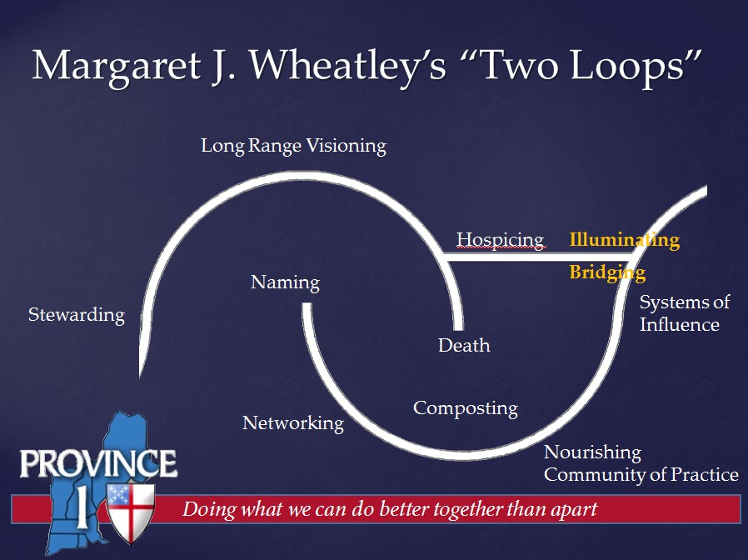
Steve Lane thanked Steve Smith on behalf of the Executive Committee and reported that we will send a gift in his name to The Episcopal church of Vermont’s Rock Point Center.

Executive Director’s Report – Julie Lytle

Julie used Margaret Wheatley’s “Two Loop” Model of Emergence to track the evolution of provincial activities since she was hired almost three and a half years ago. Wheatley’s model shows how one cycle of a group or project’s evolution comes to a close and the bridging that occurs to help a group move from one paradigm to another. It also shows how the first loop provides nourishment for the new initiatives identified on the second loop as individuals move from naming what they are seeing as a new possibility, through loosely networked like-minded individuals working on that possibility, to committed communities of practice.

Province 1, like most of the Episcopal Church Provinces, no longer functions as it was originally conceived with the province coordinating network activities that connect people/divisions from the church wide offices/desks with parallel people/divisions in the dioceses. Instead, the provincial coordinator is working with the provincial deputies and bishops, as well as diocesan staff, to identify new initiatives as they emerge and support their efforts across dioceses in such a way as they find ways to accomplish initiative better than they could apart. The only original networks that were still functional when Julie was hired was the Province House of Bishops, the Province Canons and Executives, and the Province Chancellors, along with the Province’s Executive Committee and ties with the Provincial Leadership Conference (comprised of the Presidents, Vice Presidents and Coordinators from each Province). The network chairs for the Ecumenical and Interreligious Network and the Hispanic Ministry Network announced their resignations as Julie was hired with no one available to pick up the mantle. There is some hope for convening the Campus Ministers Network.

Through a series of Forums with ministry leaders clustered by the topics of New Models of Church, Faith Formation, Young Adults, and Communications, the province learned that folks wanted opportunities to network with their peers and would participate in targeted learning for their areas of interest but no longer had the capacity (fewer staff, larger portfolios, blended roles) to offer time to create those efforts. The Sowing Seeds for God’s Mission grants were established to help launch new initiatives and the Executive Director offered Web Conferencing to gather people.
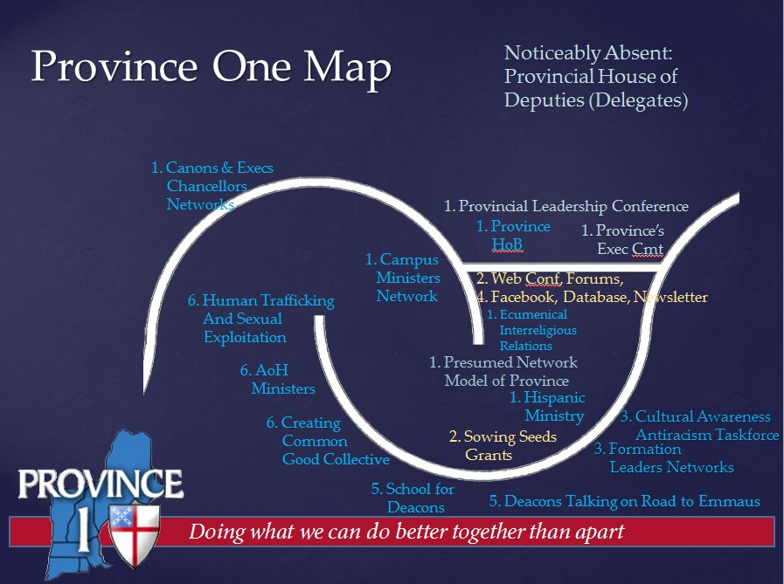
Today there are a few groups that are becoming communities of practice. The Formation Leaders network was launched at the 2014 Once and Future Church conference and plans to continue to meet annually. A Canons and Executives Sowing Seeds grant launched a Cultural Awareness and Anti-Racism Task force that has spent two years evaluating diocesan anti-racism training models and resources and is about to host a Trainers Training next weekend. Representatives from each of the dioceses have been laying the foundation for a School of Ministry for Deacons which will begin in September 2015 as a two year blended (online and physically gathered) program.

The province-wide distribution of Trinity Institute’s Creating the Common Good in Jan 2015 was the catalyst for a group of 12 to participate in the Bridges out of Poverty retreat and commit to working together to address economic inequity. Province I hosted the first (Sept 2013) and last (Mar 2015) provincial Art of Hosting Conversations that Matter with Tom Brackett. With over 60 people trained, there are signs of a new network emerging. Finally, individuals from a few of our dioceses who are working to address human trafficking and sexual exploitation are starting to communicate and share resources.

To support these efforts, the province has expanded its presence on Facebook and is using Constant Contact to mail a quarterly newsletter, eConnections, and to enable people to register and pay for events.

The current structure does not provide a good model for the Provincial House of Deputies (Called delegates in the province to differentiate from GC deputies). Many delegates have voiced discomfort making decisions when they have neither the authority nor budgetary control to enact them in their dioceses. We are experimenting with diocesan staff (W MA, RI) and GC deputies (ME) serving as delegates to see if this can be adequately addressed.

Spring Elections
Nominees were presented
- President – Stephen Lane (ME)
- Vice President – Kit Wang (ME)
- Lay Executive Council Rep –Alexizendria “Zena” Link (W MA) and Dennis Stark (RI)
There were no nominees from the floor. Provincial Synod Reps voted. Stephen Lane, Kit Wang and Alexizendria Link were elected

Announcement of New Treasurer
The Provincial Constitution defines that the Treasurer is appointed by the Executive Committee. Rich Lane has agreed to succeed Steven Smith. The transition of duties occurred on April 1, 2015 after the Provincial Books were audited by Steve Aboud in the Diocese of Western Massachusetts.

Resolutions to Discuss and Vote
AMEND Canon 1.9: Of Provinces

Steve Lane and Julie Lytle presented a resolution asking for a Canonical Revision which add more specificity to the function of Provinces and Provincial Coordinators. This resolution was drafted by a subcommittee of the Provincial Leadership Conference (the Pres, Vice Presidents and Coordinators from each of the 9 provinces who meet annually in December) after the 2014 PLC meeting in Baltimore. Steve reminded that questions about Provincial Coordinators/Coordination are being is raised because the DRAFT BUDGET from the Executive Council for the next triennium which recommends a three year shift in payments from full support ($10,000 for Province 1) in 2016 to 50% ($5,000 for Province 1) support in 2017 and no support in 2018. Additionally, Julie shared two documents -- “The Mission of the Provincial Leadership Conference (PLC) and Its Organizational and Operating Guidelines” (12/2013) and “Coordination * Communication * Facilitation * Dissemination” (12/2013) which describe and define roles and functions of Provinces and the Provincial Leadership Conference.

The Resolution was presented as follows:

Amend Canon I.9: Of Provinces
Resolved, the House of ___________________ concurring, that Canon I.9 is hereby amended to read as follows
Sec 2. The primary purposes of the Provincial system are to provide a structure which facilitates inter-diocesan collaboration to achieve Diocesan and Episcopal Church goals, and to enable more effective communications and regional advocacy of significant programmatic efforts.;
and be it further
Resolved, that the current sections of Canon I.9 be renumbered accordingly.

Explanation:
The fundamental unit of the Episcopal Church is the Diocese. Therefore, the primary purpose of Provinces is to support Dioceses in their work, particularly in those areas that because of economies of scale they are not able to do as well or at all by themselves. The Provinces also have a responsibility to respond to, and coordinate, those directives initiated by General Convention.
The Constitution and Canons of The Episcopal Church state that we will have Provinces, the Dioceses that shall be in each Province, and the power invested in the Provincial Synods. There is, however, no articulation of the purposes of the Provinces. One of the consequences of this omission is confusion about the need for and/or role of Provinces. A canonical definition of the primary purpose of Provinces provides: 1) a common reference point for initiating, developing, and evaluating Provincial ministries; 2) a basis for understanding the place of Provinces in the Church’s current and future conversations around re-structuring for ministry and governance.

Among the various tasks undertaken by the Provinces are the following:
- Staffing a Court of Review, when required, as specified in the Canons.
- Supporting the General Convention Office by providing opportunities for pre-General Convention orientation for Bishops, Deputies & Alternate Deputies.
- Identifying and electing provincial representatives to the Executive Council.
- Coordinating numerous ministry networks and associated grant programs, especially in areas seen as assets to the work underway in Dioceses. These ministry areas may include anti-racism, human trafficking, youth and young adult work, coordination of mission trips, stewardship, health ministries, Christian Formation, Ministry of Women, Latino and Indigenous groups, Diaconal development, climate issues and many others, all of which vary by Province.
- Receiving, reviewing, and submitting worthy applications for Constable grants.
- Coordinating and executing Provincial Synods.
- Offering a variety of opportunities for development of lay and clergy leaders.

There was no discussion.
Billy Boyce moved to approve the resolution. Jan Grinnell seconded. It was approved unanimously by the Provincial Bishops and Delegates present.

Resolutions Coming from dioceses/groups within the Province
Commend and Advance Baptismal Covenant Language that Reflects Our Unity with All Creation
Sandy Stayner presented a resolution from a committee that she co-chaired, and was approved at the Episcopal Church in Connecticut’s annual convention, to add creation care language to the Baptismal Covenant:
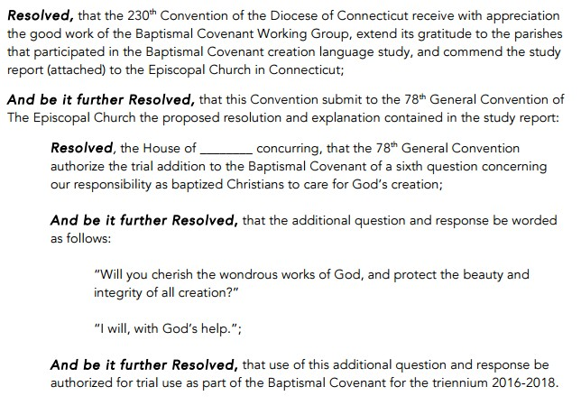
Discussion of use followed. Trial use would mean that, if General Convention approved the resolution, Bishops could decide whether or not to authorize this language for use in their dioceses. Ian Douglas identified three anticipated challenges: the legislative process, creedal concerns (if some adopt and others do not, there is no uniform use across the church thus making promises different in each context), and climate change deniers. Stephen Lane reminded that “messy is the way the church evolves.”

Tom Ely asked to explain the Standing Committee on Liturgy and Music’s view of prayer book revision (an anticipated outcome if this change is adopted). While many in the church will agree that it is time for a Prayer Book revision, the SCLM was not charged with this task by General Convention in the last triennium. This resolution could result in a call for future work of the SCLM. Tom explained that “Trial Use” does not depend on a Bishop Diocesan’s approval; if General Convention approves the resolution, priests could use without Bishop Diocesan’s approval (Constitution Article 10). If trial use is approved, the relationship between canonical and constitutional elements will beg attention.

Synod was not asked to endorse this resolution; Deputies were encouraged to support it at General Convention.

Fossil Fuel/Divest – Reinvest
Doug Fischer and Bud Cederholm introduced this resolution by inviting delegates and deputies to join a growing movement in the church that is advocating for environmental justice by asking the Church Pension Fund, the Investment Committee of the Executive Council, and the Episcopal Church Foundation to stop purchasing holdings in fossil fuel companies and to make a plan to divest from them over the next five years. The resolution recommends investing in clean energy sector and to encourage parishes to do the same.
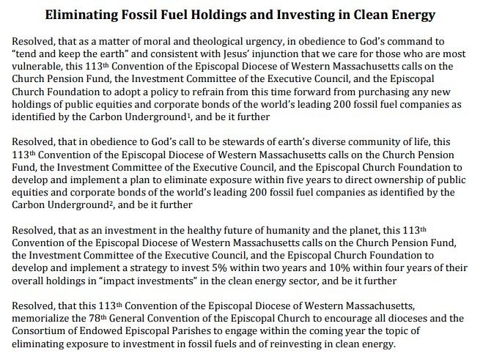
Ian Douglas recommended that it be put in GC resolution form. He also cautioned that because these groups are not under the direction of the General Convention, the General Convention can only ask groups to consider a move, they cannot legislate a change.

Funding for Mark Five
Bud Cedarholm identified a resolution that will be presented to the General convention to increase funding for the fifth Mark of Mission. He identified that he, and others, were alarmed when only $250,000 was recommended in the triennium budget. Currently there is no staff person for the Environment in the church-wide offices.
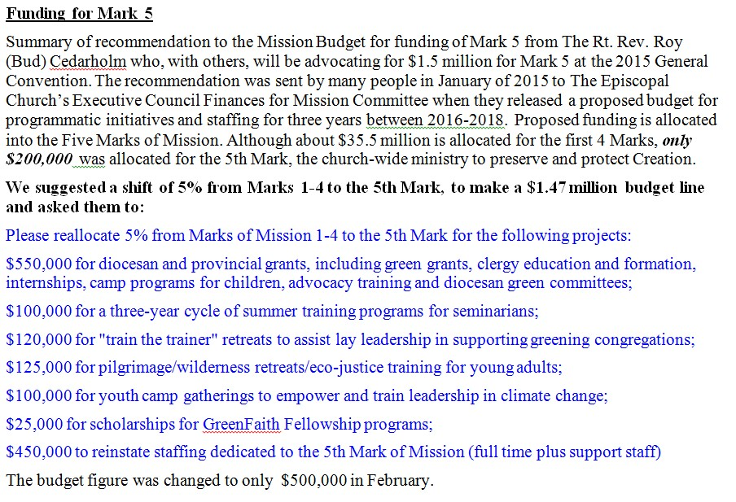
He asked deputies and delegates to send comments to PB&F 1) asking GC to hire a half-time staff member for Environmental awareness, 2) asking for funds to be available for diocesan efforts, and 3) funds to provide training to parishioners. Tanya Wallace, Clergy representative to Executive Council, identified that 90% of the petitions the Exec Council has received about the budget were not Bishops or deputies. Two-thirds of the responses were directed to Mark 5. The challenge is that in the last triennium, Mark 5 only used 18% of its available funds. There is a hope that Mark 5 can expand the Mission Enterprise Zone model to work on Environmental Justice. Steve Lane (who is also co-chair of PB&F) reminded us that options to provide feedback to the draft budget were created because of public demand. Relatively speaking, there has been little commentary on the budget. Steve encouraged us to use the online and other options or they are likely to be discontinued.

Report from Standing Committee on Liturgy and Music – Tom Ely
Tom identified that he is the “cross-over” person who serves on both the Standing Commission on Liturgy and Music and the Task Force on Marriage. Tomorrow he will speak more fully on the Task Force’s Study on Marriage (A050). Within the context of the increasing number of states that are supporting marriage equality for all persons, Tom reported that the SCLM will be proposing four liturgical options for those seeking marriage to complement
- The Witnessing and Blessing of a Lifelong Covenant
- Blessing of a Covenant Relationship – an adaption of the same gender liturgy for use by opposite gender couples
- The Form Of Solemnization Of Matrimony (1928 Book of Common Prayer)
- The Celebration and Blessing of a Marriage (1979 Book of Common Prayer)
There is a provision for generous pastoral response. Anyone can use their conscience in deciding whether or not and how to use these materials. This is true for divorce as well.
The committee is expecting a ruling on Same Sex Marriage on June 15.

United Thank Offering - Susan Howland
Susan is the Province 1 representative to the UTO Board filling an unexpired term. She described the UTO ministry of the church as encouraging an attitude of gratitude. Having been raised unchurched, she stumbled into the Episcopal church and was inspired by the women, all members of ECW. UTO is a 125 year ministry that predates Executive Council through the Women’s Auxiliary Mission (no seat, voice, or vote until 1970s). the Board is flexible in structure with representatives from all 9 provinces, 2 members appointed by the House of Deputies and Presiding Bishop, an executive Council liaison, and two paid staff. They promote and give grants ($1.5 million), as well as communicate through a blog, Facebook, and webinars. There will be three rounds of grants celebrating the 125 anniversary: Special Bishops Grant (NH – Jonathan Daniels), Young Adults Grant, and Regular grants.

Episcopal Church Women – Elizabeth Hubbacker
Elizabeth has been a parish priest for 37 years and is a cradle Episcopalian. She identified collaborative efforts of the three sisters: Episcopal Church Women, United Thank Offering and Daughters of the King. The ECW focus this year is Human Trafficking. The national ECW meeting anticipates between 300-500 people who will collect money and items in Salt Lake City for the poor, especially youth of the streets. She enjouraged those present to connect with members.

ANNOUNCEMENT
The 30th Anniversary of Deacons Celebration is in Providence on May 30. In recognition of deacons, funds are being raised to support St Mary’s Children’s Home. Contact Deacon Jan Grinnell for more info.

GENERAL CONVENTION AGENDA
Draft Schedule recommends Province Night, Sunday, June 28

including several bishops responding. Some of our deputies believe that we may need to change the budget on the floor of convention if the Exec Council does not do so before Convention.
o Provincial Coordination (Lytle)

PB&F Draft Budget
Katherine Jeffers Schori
Reception
Dinner

SATURDAY APRIL 18 AGENDA

9:00 – 12:00 General Convention Orientation (Michael Barlow, Gay Jennings, etc.)
• Preparation for the General Convention, June 25-July 3, 2015, Salt Lake City, UT

Chuck’s Notes on Orientation
Items for Synod and Deputies
• 3 hours for TEC…talk to Marian Conboy about time slot
• Include Diocesan Liaisons?…get new list
• Brochure about grants and sponsorships…McDonald
• Print new schedule for GC
• Three joint sessions…presentations on PB nominees, PB&F, Mission Days
• Utah Night – July 1st, Wednesday – Mormon Tabernacle
• Nine Legislative days
• PB Election – June 27th – St. Mark’s Cathedral
• Welcoming event for new PB late in GC
• PB will be seated in DC, November 1st
• “Green” GC
• Tablet instructions & simulation at Synod
• App for smartphones
• Persons not on the floor will be able to stay tuned in via the internet
• Tablet will be the virtual binder, plus Blue Book and C&C
• No special rules re: use of electronics on the floor
• Electrical outlets widely available on the floor
• New Rules of Order for GC
• Legislation activity to be prioritized by Dispatch of Business throughout GC
• Most resolutions will be placed initially on Consent Calendar…procedures will exist to remove to regular calendar.
• Legislative committee membership appointed by year end.
• Blue Book to be released sequentially…TREC will be first…by end of the month
• Remainder after the first of the year…everything will be translated at point of release
• Blue Book will be on GC web-site…notice of activity will be sent via Extranet
• 47% deputies are first timers…balanced M/F…21% color
• Web-sites – www.houseofdeputies.org & www.generalconvention.org
• EC working group examining how to improve attendance of deputies from poor dioceses
• Preliminary EC budget comments welcomed on GC website…soon
• Resolution for canonical change re: Provincial purpose and value to be formed and submitted for action by each Synod.
• Each Province will submit comments on Preliminary Budget urging reinstatement of support for Provincial Coordination

Projected Number | Meal | Cost per item | Total Items | Individual Item with taxes and fees | Charge on Event Brite
35 | Lunch-Fri. | $22.00 | $770.00 | 28.60 | 29.00
50 | Reception-Fri | $5.00 | $250.00 | We pay
65 | Dinner-Fri. | $27.00 | $1,755.00 | 35.10 | 26.00
50 | Box Lunch-Sat. | $12.00 | $600.00 | 15.60 | 16.00
 |  |  | $0.00
Sub Total |  |  | $3,375.00
Administrative Fee 8% |  |  | $270.00
7% State Sales Tax |  |  | $253.13
Service Charge 13% |  |  | $438.75
 |  |  | $4,336.88
1 | Room rental | $0.00 | $0.00
2 | Microphone (2 days) | $90.00 | $180.00
2 | screen (2 days) | $35.00 | $70.00
Sub Total |  |  | $250.00
Administrative Fee 19% |  |  | $47.50
6.25% State Sales Tax (on AV) |  |  | $7.81
 | Total Rental/AV |  | $305.31
Grand Total |  |  | $4,642.19

