Synod Gathering Minutes
Compiled by Sandra Stayner, Jim Curry, Julie Lytle
Doubletree Inn, Westborough MA
April 13, 2012

Opening Worship – Isaac Everett

Welcome and President’s Report – Jim Curry
To Be Added

Executive Director’s Report – Julie Lytle
Julie began by sharing parallels between the story of the disciples on the road to Emmaus after Jesus’ death and what she hopes is the work she is doing with delegates. Walking together, not really sure of what is next with the conversations about the Episcopal Church restructuring and three new Bishops being elected in the Province. Still, she trusts we will discern where to go and how to get there together as we share our stories, hear what is burning in our hearts, and work from our passions to serve God’s mission.

Julie started as Executive Director on Sept 1 in a 30% time position. Drawing from her job description, she described that her primary role is as “INITIATOR OF CONNECTIONS” and will work to empower shared ministry. This includes enhancing the effectiveness of current networks and fostering the creation of new ones, serving as resource and liaison, working with the Executive Committee and delegates to enhance communications within and across the province, and ensuring that the Synod and Preconvention orientation occur. She identified her primary accomplishments to date as conversations with the province’s bishops, bishops staffs, networks, and delegates; developing the Sowing Seeds of God’s mission grants as a means to reallocate underutilized funds to support emerging efforts in the province, enhancing the website, and utilizing AdobeConnect web conferencing to increase opportunities to meet with the Executive Committee and delegates. Of particular note were three delegate web conferences (Jan, Feb, Mar) where we discussed current diocesan efforts and began conversations about the role of delegates in the Province. A goal for 2012 is to develop clear job descriptions for each.

Treasurer Report- Jim Curry
Steve Smith prepared documents that were presented by Jim Curry (Steve was unable to attend) and discussed. He reported that revenue for 2011 slightly exceeded our budget of $107,000 and expenses were $20,000 under budget. The main contributors to this underage were:
- executive director compensation under by $7,500 on account of a vacancy in the position for part of the year
- network spending under by $11,000 on account of reduced activity.
Also, the Synod-approved budget for 2011 included a $11,000 surplus of revenue over expenses. Because of these expense underages, revenue actually exceeded expenses by $35,000.

Meeting in late November, the Synod approved a 2012 budget that reduced diocesan assessments by 35% and applied $25,000 of the 2011 surplus to fund 2012 operations. It is clear that the balance sheet is much stronger than in 2008 when we were de facto underwater.
Total assets at year-end were $115,000. Some of this is funds restricted to particular uses, most especially $22,000 restricted to environmental ministries. Unrestricted assets at year-end were $76,000. Of this amount, $25,000 has been earmarked to support 2012 operations, leaving $51,000 currently uncommitted.

Each year's financial records are reviewed by a diocesan financial administrator with this responsibility rotating among the dioceses. In 2011, the 2010 financial records were reviewed by Julie Giguere, Financial Administrator of the Diocese of VT. The 2011 financial records have not yet been reviewed.

During the year, the accounting software was updated to Quickbooks for Mac 2011 Version V 12/0/15 R16. Accounting financial records are backed up, usually weekly, and quarterly records are copied to external storage and mailed to the President of the Province. In 2012, a project is underway to update the chart of accounts and bring it into compliance with uniform accounting practices for nonprofits. Right now, the old and new charts of accounts are being run in parallel.

Proposal to Return Executive Director Position to Half Time – Jim Curry
The possibility of creating a ½ time position for the Executive Director was raised. The cost of raising the position from 1/3 to ½ time was discussed using documents supplied by Steve Smith.
- Currently the 30% ED position has a compensation package of $35,167: salary $29,29), 9% pension $2636, social security and medical taxes $2241, and continuing education $1,000. Steve created a graft to illustrate the reflects reductions of both time and salary over the past five years:

- If the ED position was returned to halftime, the compensation package would cost $56,012: salary $43,935, 9% pension $3954, social security and medical taxes $3361, continuing education $1000, and 50% healthcare $3762. This would add $13,897 to the 2012 budget and $20,845 to future budgets.
- The grant to the Synod for PLC coverage was increased by $5000 in 2012 so the actual amount needed from the synod is $8897 which is available in the synod surplus. The amount of PLC contributions for the future is unclear, though early Executive Council conversation seem to indicate the increase could continue as the offices of the Episcopal Church are restructured.
- Historically, 70% of the diocesan assessments have funded the ED position.

- If the decision is to continue the ED position at 50% in the future, the cost to dioceses would return to the 2011 assessment level in 2014.
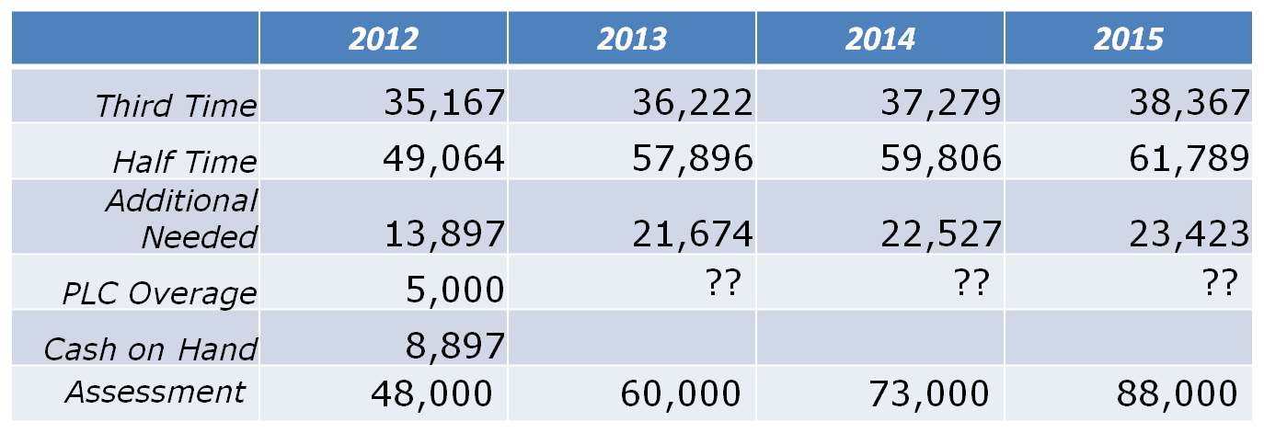
SYNOD COMMENTS
- Bishop Wolf thought that Julie’s work around the use of technology would benefit her diocese but is not sure how much money they could release at this point
- Lee commented that having a ½ time Executive Director for the Province might be very useful if the National Church continues to diversify.
- Tom Ely noted that we can vote to support raising diocesan assessments but until dioceses go through their budget processes it is not possible to know how much money will be made available.
- We don’t yet know how much support we will receive from General Convention.

A proposal was made to raise Exec Dir package to half time effective July 1. The resolution passed with one abstention (delegate felt she did not have authority to vote on budgetary issues without discussing with her Bishop who was not present.) Money will come from reserves for July – Dec 2012. A request will be sent to each of the dioceses for their 2013 budget to reflect a return to their assessment from the 2011 budget

Environmental stewardship – Stephanie Johnson
Stephanie presented updates on her work. This position is 10 hours/week funded solely by Province 1 Bishops. Her travel allowance is funded by a grant from Province 1. The position was created to help parishes reach the goal of reducing their energy use by 50%, the goal of the Genesis Covenant from the National Church Office.
Turn off the light for God’s sake campaign is a campaign to help parishes reduce their carbon footprint. Stephanie has met with different groups to talk about this ministry. She has also created a survey for parishes to find out how well they are doing with reducing their carbon footprint. She noted a lot of enthusiasm among some, as well as some burnout among volunteers who have been working at this for a long time. Many parishes are eager to begin but not sure where to start. There are some large projects happening in some dioceses such as solar panels in VT. Environmental Stewardship information is now on Province 1 website. Stephanie is building on the efforts of other denominations so we don’t duplicate what has already been done.

Conversation was opened to the floor. Bishop Curry wondered if part of our conversation should be about closing buildings that are not environmentally sound. Dennis Stark suggested limiting use of church elevators. Stephanie was asked if any capitol projects that are financially helpful to parishes could be made available on Province 1 website. Stephanie would like to develop the concept of a speakers bureau – people who have been successful at reducing the carbon footprint of their church and are willing to share their learning with others. This could then be made available on Province 1 Website. Bishop Curry noted that Stephanie’s work is a wonderful example of what the province can do.

Report from Executive Council- Lee Crawford and Anne Watkins
- Lee shared snapshots/snippets of what they have been about this past year.
- Anne described her work, teams and councils she is serving on.
- There has been a lot of conversation about the structure of church – what happens in national church and at a Provincial and diocesan level.
- It was decided that Anti-racism training should be a part of every meeting of the EC
- We must continue to pay attention to the way we offer loving service outside the church to poor and marginalized people.
- Constable fund – council worked to see how fund applied for and how grants are made. Perhaps could join with sowing seeds of mission
- Special initiatives in Christian formation. Normally applied to church wide staff. Now broadening access to that fund. Will first attempt to broaden access to Provinces.
- Lee will be retiring from EC this year. She was thanked for her good work. Synod will gives a check for $100.00 to Cristola in thanksgiving for her work on EC.

UTO – presentation by Barb Tinder
Noted that ECW is experiencing a time of change. It is their goal to help parishioners make gratitude an everyday experience. A discussion ensued about how a little “loose change” can make a change in people’s life. UTO is about service, changing attitudes and providing gifts and opportunities for other people to start a program, begin a program and make change. UTO – our change, changes lives.

ECW – Marjorie Reeves-Briden and Shirley Grieman
Many women serve the church in a variety of different ways under many names; Many women serve their parish without belonging to a group. There is some feeling in the province that the need for ECW has passed. ECW is most vital when they receive support of Bishops and diocesan leadership. Each diocese assessed yearly dues of $250.00. They would like to have a fund that supports women seeking their own spiritual development. Should we sponsor more events to recognize women and women clergy? The trafficking of young girls is a big problem that we should all be concerned about. ECW provides refreshments for diocesan events

Call for nominations- Jim Curry
President and Vice President alternate between bishop and clergy or lay. They serve a 3 year term.
Sandra Stayner, was elected to serve as the President.
Bishop Lane from the Diocese of Maine was elected to serve as the Vice-President.
Charles La Fonde was elected to serve on Executive Council
The elections were unanimous.

Remarks from new president- Sandra Stayner
This is a time of enormous change in the church and in the world
How can the church “get there early” so that we are prepared for the change that is coming, instead of trying to catch up with change that has occurred?
Can we learn to anticipate change and be nimble in response?
What role can the Province play in this?
The Spirit is like a fire that goes underground and then pops up. Where are fires popping up around us? What are we excited about?
Who will notice where the fires are?
This is an exciting time as the Spirit moves among us and brings change. Change is here to stay.
Province hopes to provide space where conversations can be shared
We would like our web-site to will provide opportunities to share our passions and best practices across the Province.

Thoughts were then shared in response to the following questions:
What can we share with the province? What do we need from the province?
Where are the fires in our dioceses and how can we share what is happening with the province?

Are there new ways of being church, doing missions, best practices that we can share with each other?

The diocesan delegates will have a monthly video conference at which they will continue this discussion.
Closing Worship – Isaac Everett

